SIMATS ENGINEERING
ASSESSMENT TOOL 3

COURSE NAME: Database Management Systems
COURSE CODE: CSA05
COURSE OUTCOME COVERED
CO2: Apply the relational model, relational algebra, SQL query structures, and views
to solve database querying and data manipulation problems. (BL3, BL6)
Activity Tool : Debugging &amp; Optimisation Task (Low)
Assessment Tool Weightage: 30%

QUESTIONS Total Marks: 50
1 Identify and fix the error in the given SQL query that uses incorrect JOIN syntax and returns duplicate results.
ANSWER:
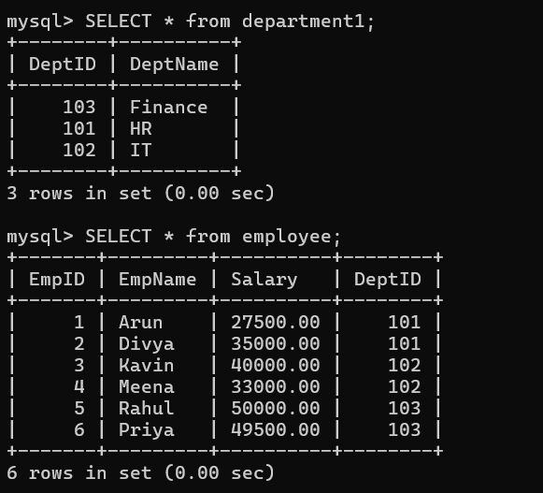
Incorrect Query:
SELECT e.emp_name, d.dept_name
FROM Employee e, Department d
WHERE e.dept_id = d.dept_id OR d.dept_id = 102;
Error:
- No JOIN condition is specified.
- Produces a Cartesian Product (duplicate/unwanted rows).
- 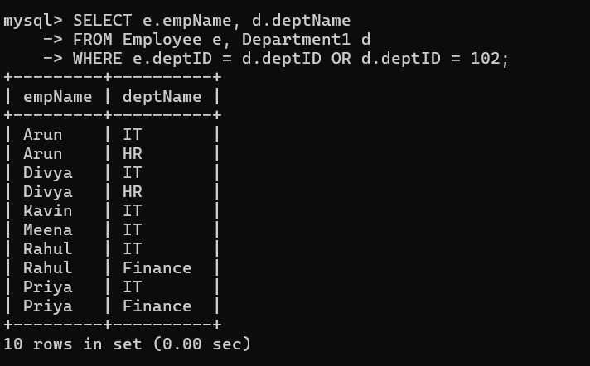
Correct Query:
SELECT e.emp_name, d.dept_name
FROM Employee e
INNER JOIN Department d
ON e.dept_id = d.dept_id;
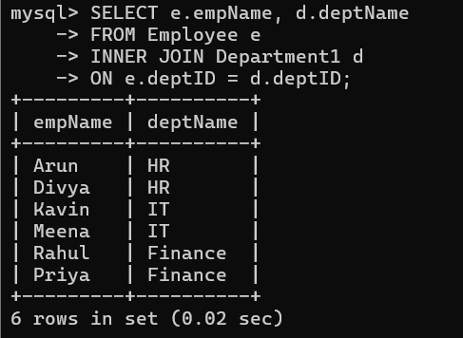
2 The following sub-query returns incorrect results due to a missing correlation. Debug and rewrite it correctly.

Incorrect Query:
SELECT empName, salary
FROM Employee
WHERE salary >
(
SELECT AVG(salary)
FROM Employee
);
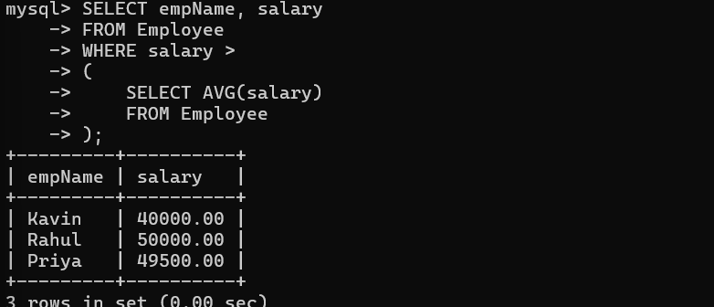

Error:
- Compares salary with the company average instead of the employee's department average.
Correct Query:
SELECT e1.empName, e1.salary
FROM Employee e1
WHERE e1.salary >
(
SELECT AVG(e2.salary)
FROM Employee e2
WHERE e2.deptID = e1.deptID
);
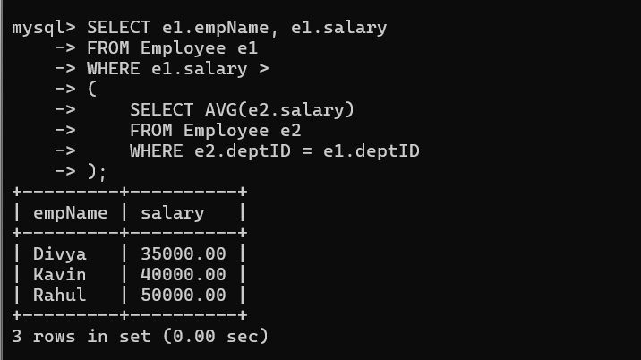
3 A given SQL view definition causes errors when queried. Identify the issue and rewrite a correct and optimized view.
Incorrect View:
CREATE VIEW EmpDeptView AS
SELECT empName, deptName
FROM Employee;
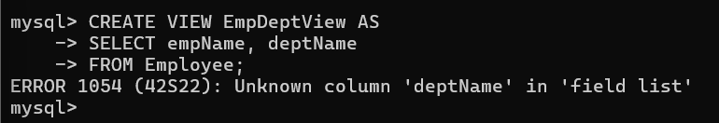
Error:
The column dept_name does not exist in the Employee table.
Correct View:
CREATE VIEW EmployeeView AS
SELECT EmpID,
EmpName,
DeptID,
Salary
FROM EMPLOYEE;
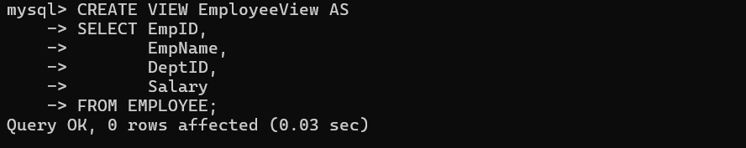

4 Debug the given relational algebra expression that produces incorrect output for a natural join operation.
Incorrect Expression:
EMPLOYEE ⨝ DEPARTMENT
Error:
- If common attributes do not have the same name, Natural Join gives incorrect or empty results.
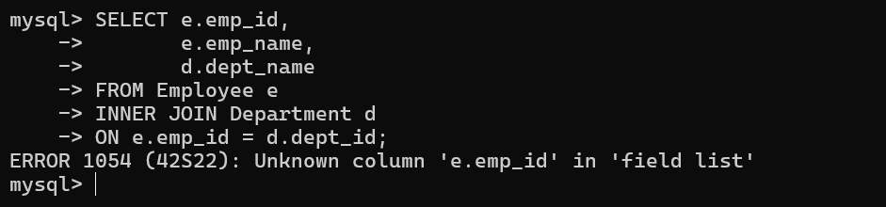

Correct Expression:
EMPLOYEE ⋈ EMPLOYEE.DeptID = DEPARTMENT.DeptID DEPARTMENT
or
EMPLOYEE ⋈DeptID DEPARTMENT
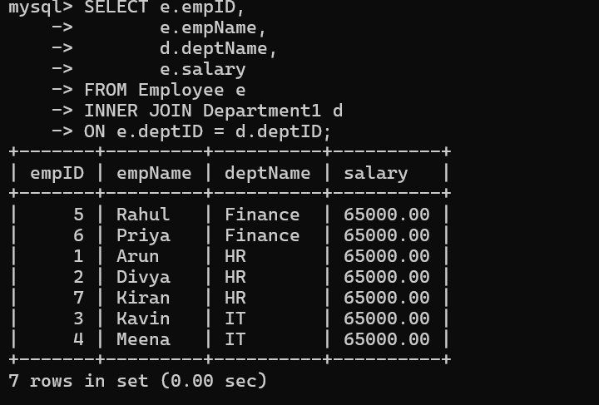

5 The SQL query below violates referential integrity. Identify the violation and modify the statements to enforce proper constraints.

Incorrect SQL:
INSERT INTO Employee
VALUES (5,'Kiran',105,45000);
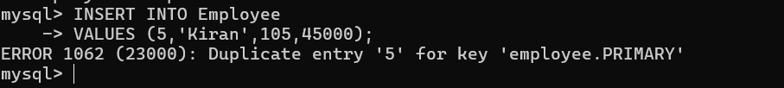Error:
- Foreign Key violation.
Correct SQL:
INSERT INTO Employee
VALUES (7,'Kiran',45000,101);
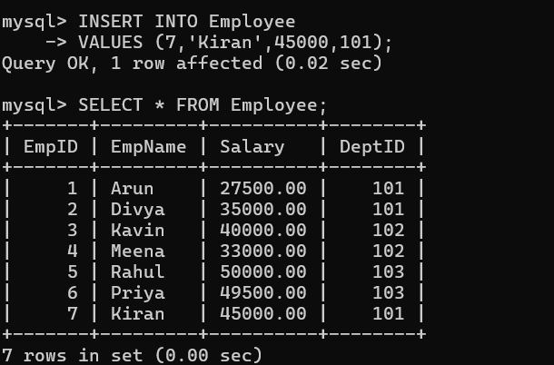

6 Given an inefficient SQL query with nested loops, rewrite it using JOIN to optimize performance.
Inefficient Query:
SELECT empName,
(
SELECT deptName
FROM Department1
WHERE Department1.deptID = Employee.deptID
) AS Department1
FROM Employee;
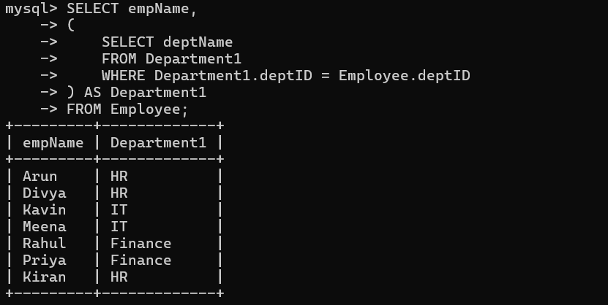
Optimized Query:
SELECT
e.empName,
d.deptName
FROM Employee e
INNER JOIN Department1 d
ON e.deptID = d.deptID;
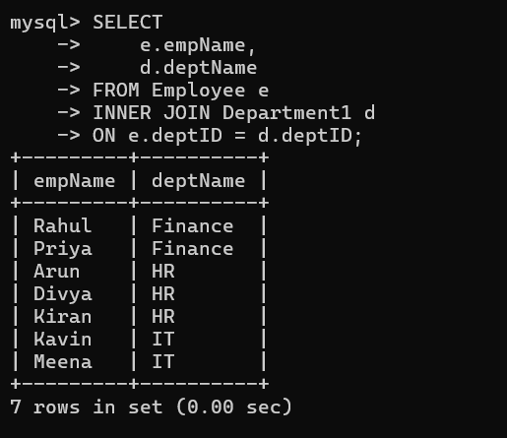
7 The GROUP BY query below produces wrong aggregation results. Debug the query and explain the error.
Incorrect Query:
SELECT DeptID,
EmpName,
AVG(Salary)
FROM EMPLOYEE
GROUP BY DeptID;
Error:
- EmpName is neither aggregated nor included in GROUP BY.
Correct Query:
SELECT DeptID,
AVG(Salary) AS AverageSalary
FROM EMPLOYEE
GROUP BY DeptID;
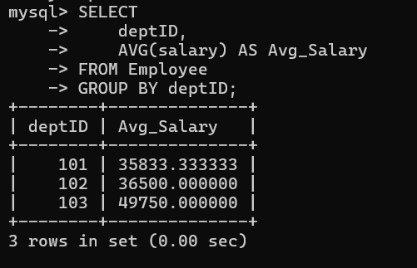
Explanation:
- Every selected column must either:
  - appear in GROUP BY, or
  - use an aggregate function (AVG, SUM, COUNT, etc.).

8 Identify and fix the logical error in a given SQL UPDATE statement that unintentionally modifies all rows in the table.
Incorrect Query:
UPDATE Employee
SET salary = 65000;
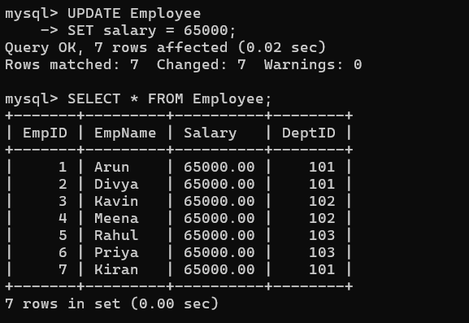

Error:
- No WHERE clause.
- Updates every employee.
Correct Query:
UPDATE Employee
SET salary = 65000
WHERE empID = 2;
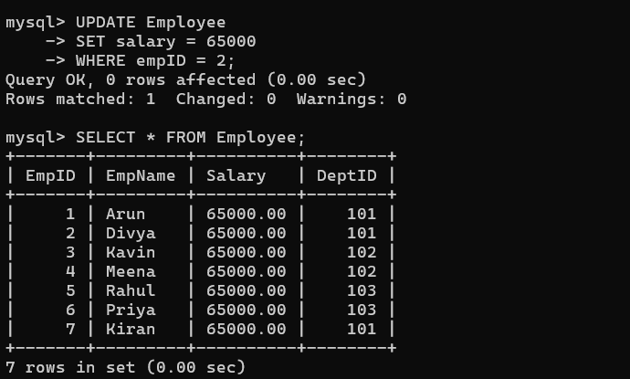

9 Optimize the given multi-table SQL query by restructuring sub-queries into JOINs and using appropriate indexes.
Inefficient Query:
SELECT
empName,
(SELECT deptName
FROM Department1
WHERE Department1.deptID = Employee.deptID) AS deptName,
(SELECT MAX(salary)
FROM Employee e2
WHERE e2.deptID = Employee.deptID) AS max_salary
FROM Employee;
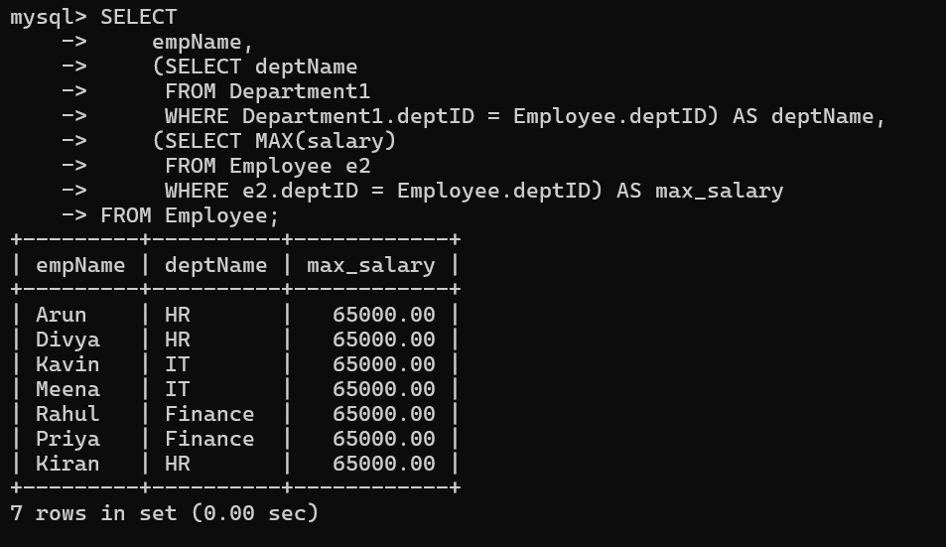
Optimized Query:
SELECT
e.empName,
d.deptName,
t.max_salary
FROM Employee e
INNER JOIN Department1 d
ON e.deptID = d.deptID
INNER JOIN
(
SELECT deptID, MAX(salary) AS max_salary
FROM Employee
GROUP BY deptID
) t
ON e.deptID = t.deptID;
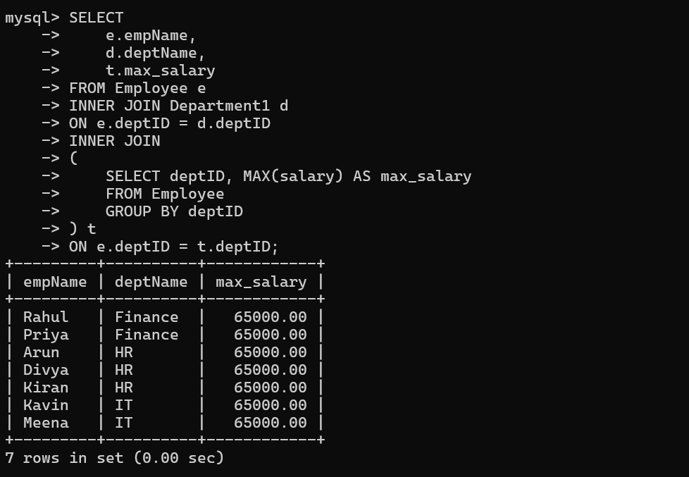
10 Debug a given relational calculus expression that returns an empty result set due to incorrect quantifier usage.
Incorrect Expression:
{
S.Name |
STUDENT(S)
∧
∀E (ENROLLMENT(E) ∧ E.StudentID = S.StudentID)
}
Error
- Uses the universal quantifier (∀) incorrectly, which results in an empty set because it requires every enrollment tuple to belong to the same student.
Correct Expression:
{
S.Name |
STUDENT(S)
∧
∃E (
ENROLLMENT(E)
∧ E.StudentID = S.StudentID
)
}
Explanation:
- ∃ (there exists) checks whether a student has at least one enrollment.
- ∀ (for all) is only appropriate when every tuple must satisfy a condition.
SELECT e.empName
FROM Employee e
INNER JOIN Department1 d
ON e.deptID = d.deptID;
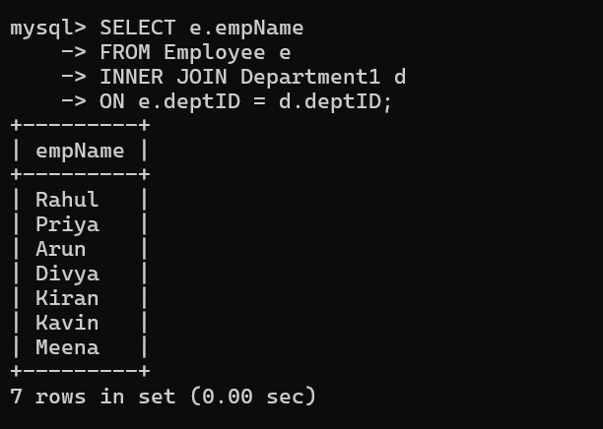

Code of Conduct:
I _M.V.PREETHASHRI(192524476)__ (Name / Reg No) certify that this submission is my original work and that I have adhered to the guidelines specified for this assessment.
I understand that any violation of academic integrity rules will result in disciplinary action.
Signature of the student:M.V.PREETHASHRI

